Tigray Church & Danakil Depression Tours
Mode of Transport: Surface and Flight
Duration: 6 days / 5 nights
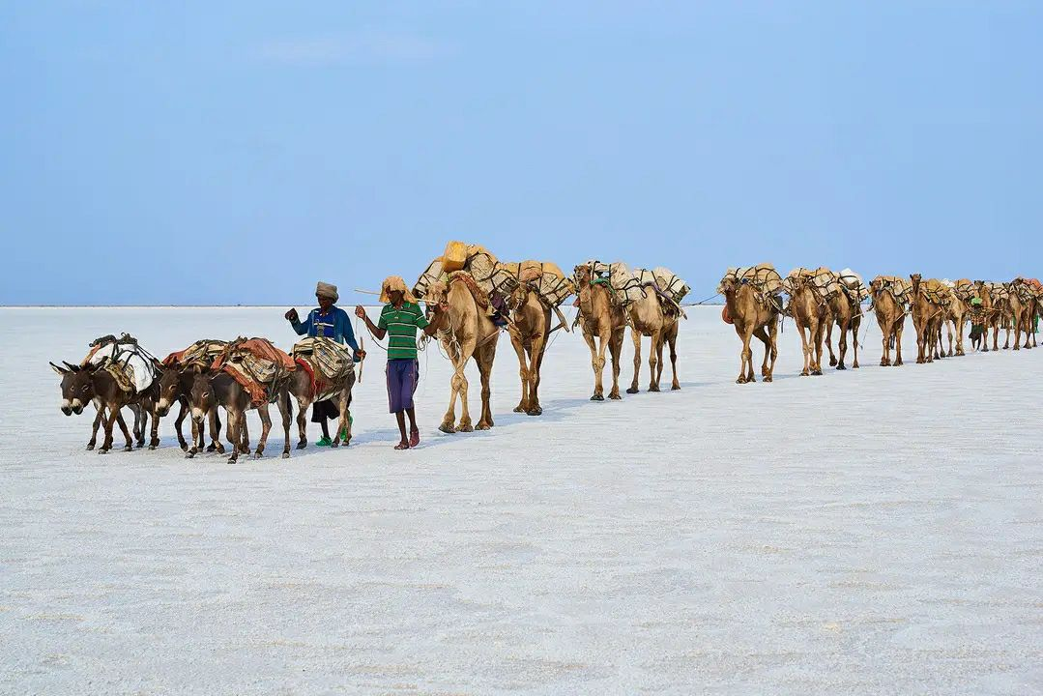
Day 01: Addis Ababa City Tours
Up on arrival at Bole international airport and met by our representative and transfer to hotel. After check in to hotel you will have city tour of Addis, Which includes National Museum- the home of the famous complete hominid fossil remain of Lucy dates 3.2 million years back, Mount Entoto- panoramic view point at the highest peak in Addis with an altitude of 3200 meter above sea level, trinity cathedral- a beautiful church with a baroque style of European architecture unique to both Ethiopia and Africa, Ethnographic museum and Merkato (the largest open air market in Africa). Overnight in Hotel
Day 02: Fly Addis Ababa to Semera and Drive to Hamedella
This day after breakfast you will take to airport your flight to Semera. You will meet our team upon arrival and drive to Hamedella visiting beautiful landscape of solidified lava, rock, sand and occasional palm lined oasis after you pass several small hamlets start visiting Hamadella village total population of more than 500 people to see the life style of the local Afar people. Finally, precede to Salt Lake Asale a huge salty lake where you will swim in a natural pool while enjoying sunset reflections of the salty ground. Overnight camping at Hamedella
Day 03: Visit Dallol Then Drive to Erta Ale
In the Morning tour Drive to Ragad (Asebo), the place where the localities are mining salt. Look the activity of breaking the salt from the ground, cutting in to rectangular pieces and loading on camels. You drive ahead to Dallol and visit the difference landscape formed by volcanic activity (125 meter below sea level, one of the lowest and hottest places in the world) colorful salts mining and different terrestrial places formed by volcanic activity like bubbling oily lake creates a different experience of your trip. Then we back to hamadella for lunch then proceed to Ertale. We spend the night watching the dramatic action of the boiling lava. Ertale ranks one of the most alluring and physically challenging natural attractions anywhere in Ethiopia. It is a shield volcano with a base diameter of 30 km and 1km square caldera at its summit. Ertale contains the world’s only permanent lava lake. Ertale is 613 meters, with a lava lake, one of only five in the world, at the summit. It is notable for being the longest existing lava lake, present since the early years of the twentieth century. Overnight camping at Ertale
Day 04 Drive Erta Ale to Hawzen via Mekelle
After Breakfast we will drive to Hawzen via Mekelle. On the way will visit the Church of Abreha wa Atsbeha their bodies are claimed to be entombed in the church. At one time the church served as a monastery but now operates as a parish church the ceiling was blackened by soot due to Queen Gudit setting a fire in the building nine centuries earlier. Overnight in Hawzen
Day 05 Visit Gheralta Cluster Churches of Abuna Yemata Guh
After breakfast we will visit the church of Abuna Yemata Guh. It is a monolithic church dedicated to Abuna Yemata (also referred to as Abba Yem'ata), one of the Nine Saints. It is situated at a height of 2,580 meters and has to be climbed on foot to reach. It is notable for its dome and wall paintings dating back to the 5th century and its architecture. After lunch you will drive to Axum visiting enroute Yeha 5th century Temple displaying incredible skills in stonework and is in fact the oldest building still standing in Ethiopia. Overnight in Axum
Day 06 Fly Axum to Addis Ababa
After breakfast you will start to visit Axum, a city more than 2500 years of history, once the center of a great empire and ancient civilization, home of the original Ark of covenants. Axum is the prime historical site in the north of Ethiopia. Take a city tour that include the St. Mary‟s Church, the sanctuary Chapel which is the repository of the „Ark of covenant‟, the coronation yard, Stelae Park, Tomb of Kaleb and his son Gebre Meskel, Ezana‟s Inscriptions, Queen of Sheba‟s Bath, Queen of Sheba‟s palace ruins and Axum Museum. Later drive to airport your flight to Addis Ababa and end of the tours.

